### Piezo sensors

Piezo sensors were put on top of the xylophone keys to detect the solenoids hitting the keys. They were connected to a comparator circuit that compared the voltage from the piezo sensor and the reference voltage of the voltage divider at the non-inverting input. The output of the comparator circuit was connected to the myRio so whenever the output was high, the LabView program on the myRio played the corresponding note through a speaker. The myRio was the preferred microcontroller since it already had a built-in audio output.

**Figure 1.1b.** Comparator PCB

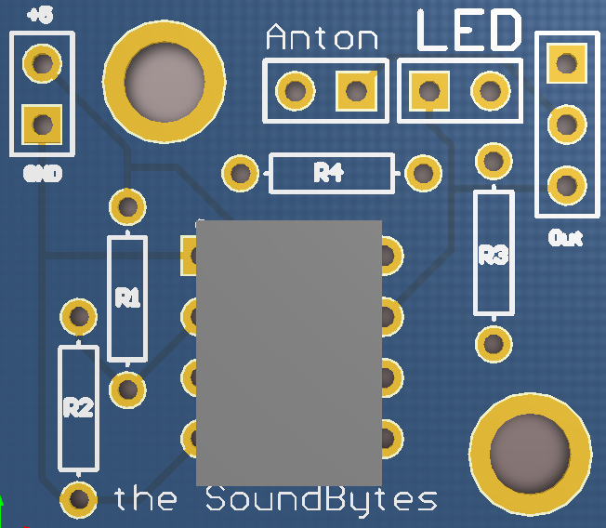

**Figure 1.1a.** Piezo sensors on the keys connected to the comparator

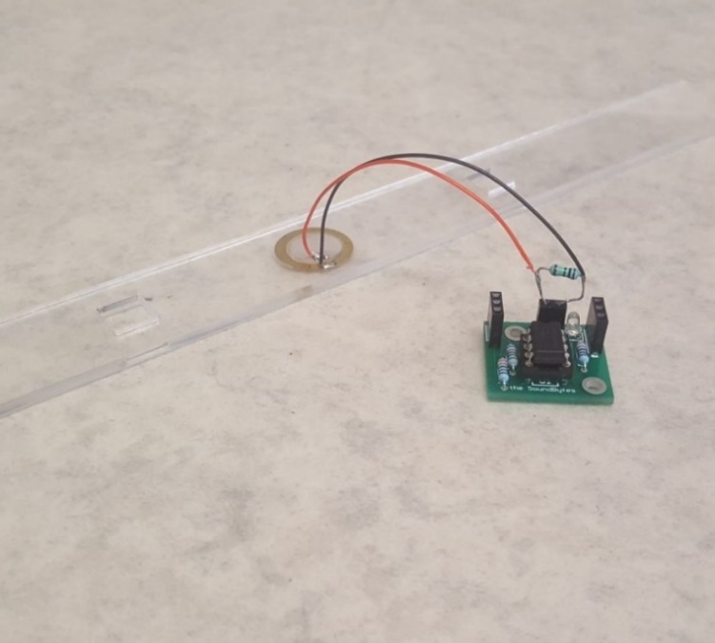

**Comparator circuit**

After making the initial comparator circuit using a LM741[1] and a voltage divider, several values of resistors were tested and it was found that a sensitive reference voltage was found to be around 0.2V that would detect the impact of the solenoid upon the piezo sensor. An LED was also placed at the output as an indicator. This circuit is seen in Figure 1.2a

R1 = 8000 Ohms and R2 = 330 Ohms.

Where V is the supply voltage (5 V) there for .

The circuit worked very similar to the final PCB and circuit design shown in Figure 1.1b and 1.2, the only important difference being that the LM741 is powered by -15 and +5 volts whereas the LM311 can be powered by Ground and +5 volts. There were 12 of these circuit connected to each other and to the 12 xylophone keys and in turn connect to 12 individual inputs on the myRio.

After tests were done, there were problems with the piezo sensors when they were used for around 20 seconds, the LEDs indicated that the comparators stopped responding to the solenoid hits. This was fixed by adding a resistor in parallel with the piezo sensor to provide a better path to ground. Later it was noticed that there was -15 V at the output of the comparator sometimes, which could damage the myRio, therefore the circuit was slightly modified and a new comparator was added: LM311. This comparator could function of off ground as negative voltage supply so the danger of damaging the myRio was no longer there. The new circuit can be seen in Figure 1.2b.

This leads to the LabView code that was used on the myRio to play the different sounds for each individual key.

**LabView code**

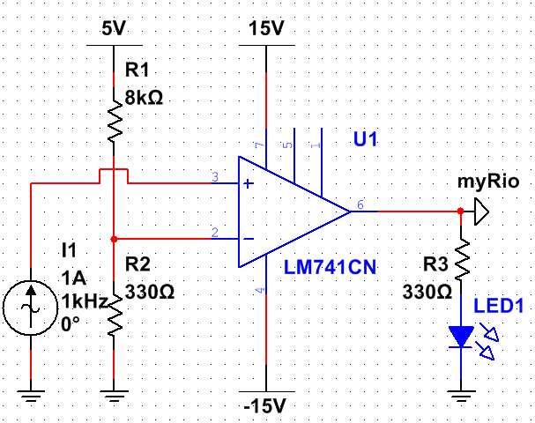

**Figure 1.2a.** LM741 comparator circuit

**Figure 1.2b.** LM311 comparator circuit

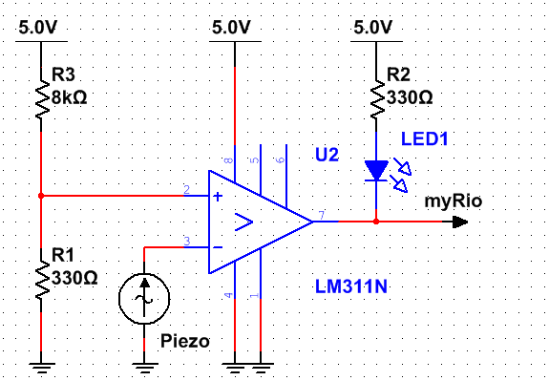

The code to play the different notes was made in LabView. The myRio cannot directly output a wav. or mp4 format files to the audio output therefore the wav. files of the xylophone notes which were obtained from soundpacks.com[2], were converted to a waveform and stored as an 1D array Y seen in Figure 1.3. This was all done offline since the myRio cannot do the converting in real-time according to this forum post [3], which was helpful in the development of the converter.

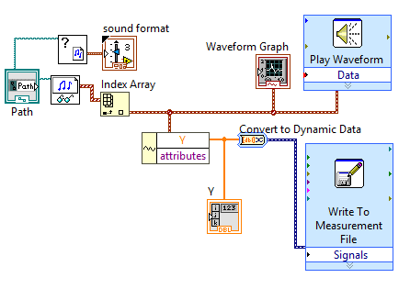

**Figure 1.3.** Converting wav. files to waveforms with help from [3].

This array was then converted to a constant and moved to the main program seen in Figure 1.4.

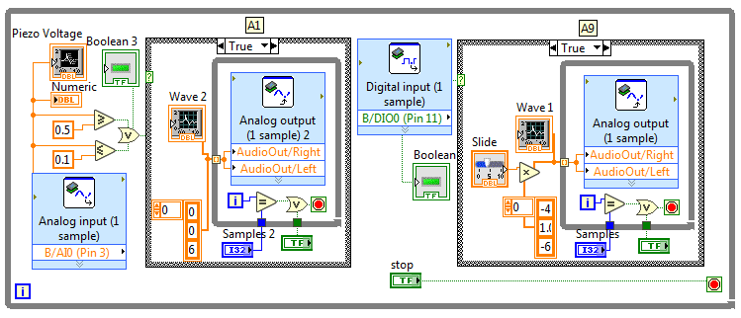

**Figure 1.4.** LabView code for analog and digital piezo inputs

This code looked at the input from the pin to which the comparator was connected to and whenever it was high, it played the waveform from the 1D array through the audio output. The waveform was played at 44,400 samples a second, the number of samples played could be set to any number and the volume was changed by multiplying the amplitude of the waveform. The front panel (interface) for testing can be seen in Appendix A.

This code was then expanded to 12 inputs and 12 waveforms for all the xylophone keys. The real-time module of the myRio was then used to store the code onboard and execute it every time the myRio was started up.

**Speaker**

A speaker which would play the xylophone notes was installed and an amplifier circuit connected it to the myRio output. This circuit allowed to tune the volume and gain of the speaker since it did not come with any inbuilt controls.

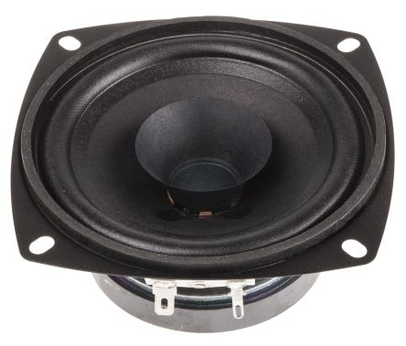

**Figure 1.5.** Visaton Speaker [5] for the xylophone.

The datasheet [5] stated that the speaker was capable of outputting 86 dB between 80 and 20000 Hz frequencies which was loud enough to play with the rest of the orchestra. The issue was that the signal from the myRio needed to be amplified.

An amplifier circuit was built following the instructions from [6]. This circuit allowed the user to control both volume and the gain of the signal using potentiometers. This circuit can be seen below:

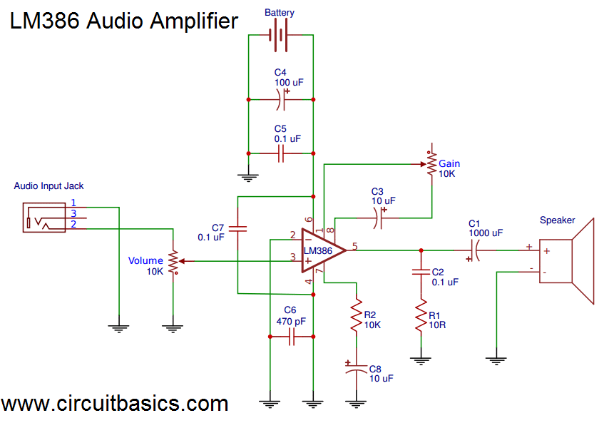

**Figure 1.6.** Amplifier circuit with volume and gain controls [6].

This circuit used the LM386 chip for amplification. A 9 V battery was used as the power supply, but a myRio +15 V and ground could also be easily used as the LM386N-4 [7] chip can support up to 22 V as a power supply. The designed PCB can be found in Appendix A.

This circuit was later used to amplify the microphone input for the Tesla coil setup, but it was later found out that the circuit could pick up the signal from the Tesla coil wirelessly, without a microphone.

Average noise of the piezo was measured at 0.25 V with a light touch to the piezo the voltage would rise to about anywhere between 0.5 and 0.7 volts and a stronger press would result in a peak of around 1 to 1.5 volts

Initial resistor values: R1 = 3300 Ohms and R2 = 330 Ohms. (0.091)

Best after test: R1 = 8000 Ohms and R2 = 330 Ohms. (0.04)

**Appendix A**

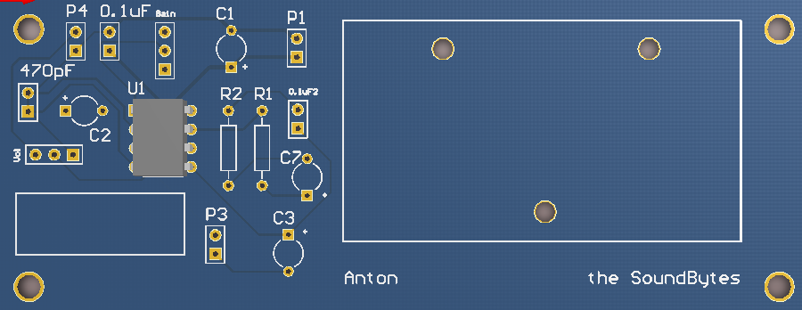

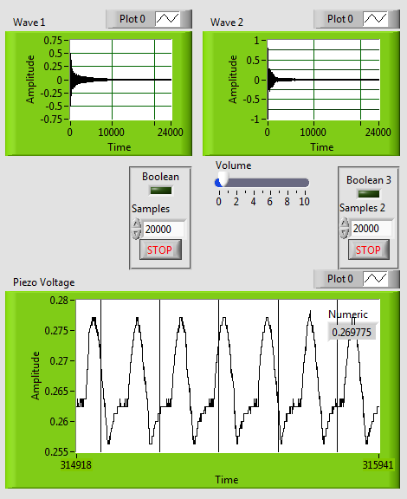

# References

[1] <https://www.jameco.com/Jameco/Products/ProdDS/840763.pdf>

[2] <https://soundpacks.com/free-sound-packs/xylophone-samples-pack/>

[3] https://www.labviewmakerhub.com/forums/viewtopic.php?f=14&t=372&sid=6eefbf8b8e0023df0de644daf7a99954&start=10

[4] <http://theremin.music.uiowa.edu/>

[5] https://docs-emea.rs-online.com/webdocs/112b/0900766b8112b84a.pdf

[6] <http://www.circuitbasics.com/build-a-great-sounding-audio-amplifier-with-bass-boost-from->the-lm386/

[7] http://www.ti.com/lit/ds/symlink/lm386.pdf